TO SUPPLY LEFTOVER FOOD TO POOR

Introduction
The project "To supply leftover food to the poor" aims to leverage the Salesforce platform to streamline the process of collecting surplus food from various sources and distributing it to those in need. By utilizing Salesforce's robust features and functionalities, the project intends to create an efficient and transparent system for managing food donations, coordinating with volunteers. and ensuring timely delivery to beneficiaries
Project Overview
The primary objective of this project is to create a platform leveraging Salesforce technology to efficiently connect surplus food from various sources with organizations or individuals in need. This initiative aims to miumize food wastage and alleviate hunger by facilitating the redistribution of excess food to those who are food insecure.
Ideation Phase
- Problem Statement
Every day, large quantities of edible food are wasted in restaurants, hotels, events, and households, while poor and homeless people struggle to get daily meals. There is no organized system to collect surplus food and distribute it to those in need efficiently and safely. This leads to:
  - Food wastage due to lack of timely collection
  - Hunger among underprivileged communities
  - Lack of real-time communication between donors and NGOs
  - No proper tracking of food donations and beneficiaries
The project aims to create a technology-driven platform to connect food donors with NGOs/volunteers and deliver safe leftover food to needy people.
- Empathy Map Canvas

Category | Details
Who are we empathizing with? | Needy people (homeless, orphans, slum dwellers), NGOs, Donors (restaurants, catering services, households)
What do they see? | Food thrown away, lack of support systems, hunger, waste of resources
What do they hear? | “Food is expensive”, “No system to donate easily”, “Difficult to reach needy people”

Category | Details
What do they say/do? | NGOs manually search for donors, Poor people beg for food, Donors throw food due to no pickup system
Pain Points | Food waste, hunger, logistic challenges, lack of awareness & coordination
Gains | Easy food donation, timely delivery to poor, reduced food waste, social impact
- Brainstorming

Idea | Description
Mobile App/Website | Donors can register and update available food, NGOs/volunteers get alerts
Geo-location Tracking | Track donors and nearby needy locations in real-time
Pickup & Delivery System | Volunteers pick food from donors and distribute
Food Safety Check | Heat sealing, quality timestamps, hygiene instructions
Notification System | Alerts for food availability and urgent pickups
Partnership Model | Tie-ups with restaurants, hostels, event halls
Feedback System | Donors and receivers rate service to improve operations

Project Planning Phase
- Project Objectives

Objective | Description
Reduce food wastage | Collect surplus food instead of disposing it
Feed underprivileged people | Provide timely meals to homeless and needy
Real-time donor-volunteer coordination | Immediate alerts and food pickup system
Ensure food safety | Follow hygiene and freshness guidelines
Encourage social responsibility | Promote donation culture

- Scope of the Project In-Scope
  - Donor and NGO/Volunteer registration
  - Real-time food availability posting
  - Live tracking & notification alerts
  - Volunteer pickup and distribution workflow
  - Food quality timestamp tagging
  - Dashboard for tracking donations
Out-of-Scope
  - Long-term food storage
  - Cooking meals from scratch
  - Government subsidy or financial transactions
- Project Deliverables

Deliverable | Description
Web/Mobile App | Donor & volunteer interface to manage food donations
Database System | Store donor, NGO, and food records
GPS-based Tracking | Track food pickup and delivery
Notification System | Alerts for nearby food pickups
Reporting Dashboard | Track donation history & beneficiaries
User Manual | Instructions for users

Requirement Analysis Phase
- Functional Requirements

Requirement | Description
User registration | Donor, NGO, Volunteer sign-up
Food donation entry | Donor enters details like food type, quantity, pickup time
Real-time alerts | Notify NGOs & volunteers when food is available
NGO approval system | Admin verifies and approves registered NGOs
Volunteer assignment | Assign volunteers for food collection & delivery
Food pickup tracking | Track status (Pending → Picked → Delivered)
Location tracking | GPS-based donor and delivery location support

Requirement | Description
Food expiry validation | Warn/block if food expiry time is near
History records | Show donation, pickup, delivery history
Reports & dashboard | Graphs and charts for food saved, beneficiaries
- Non-Functional Requirements

Category | Requirement
Performance | App should respond under 2 seconds
Scalability | Can support multiple cities & volunteers
Usability | Mobile + web access, easy user interface
Security | Role-based access (Donor, NGO, Volunteer, Admin)
Availability | Cloud based 24/7 access
Reliability | Data backup and recovery
Data Integrity | Validation rules for safe food and time stamp

Project Design Phase

Salesforce Developer Account Creation
  - To sign up for a salesforce account
  - To login to your salesforce account
  - Account activation

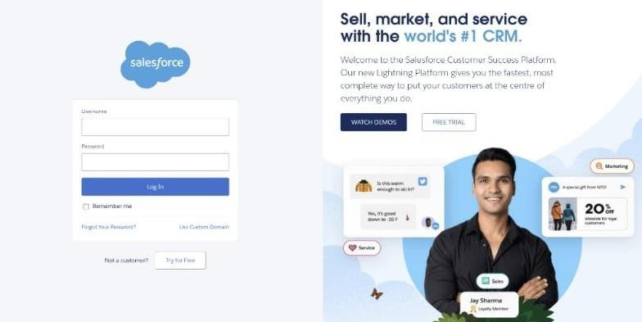

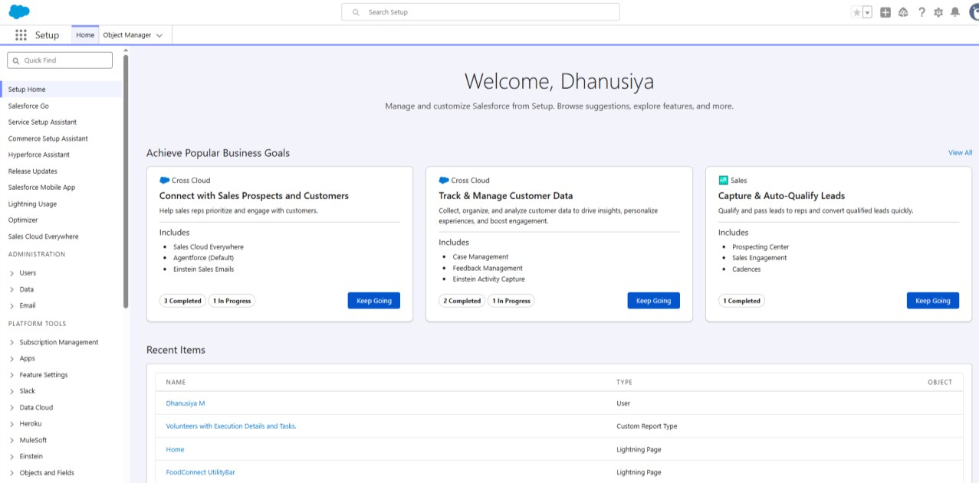

Object Creation Venue:
Stores information about locations where leftover food is collected or stored before distribution, including details like address, contact person, and facility capacity.

To create an object:

From the setup page >> Click on Object Manager >> Click on Create >>Click on Custom Object.

  - Enter the label name >> Venue
  - Plural label name >> Venues
  - Enter Record Name Label and Format
  - Record Name >> Venue Name
  - Data Type >> Text
  - Click on Allow reports and Track Field History,Allow Activities.
  - Allow search >> Save.
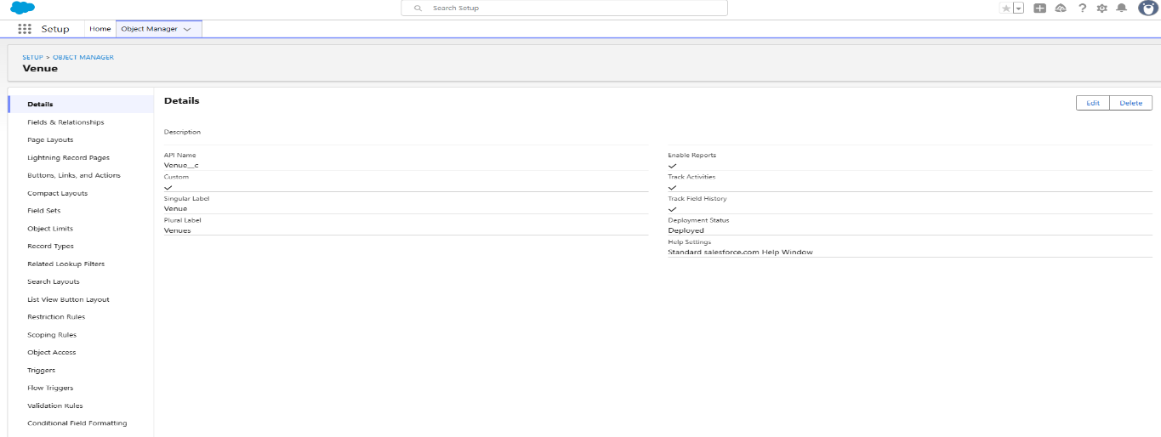

Task:
Logs specific tasks related to food collection, transportation, and distribution, assigned to volunteers or teams, ensuring accountability and tracking completion status.

To create an object:

From the setup page >> Click on Object Manager >> Click on Create
>> Click on Custom Object.

- Enter the label name>> Task
- Plural label name>> Tasks
- Enter Record Name Label and Format
  - Record Name >> Task Name
  - Data Type >> Text
- Click on Allow reports and Track Field History,Allow Activities
- Allow search >> Save.
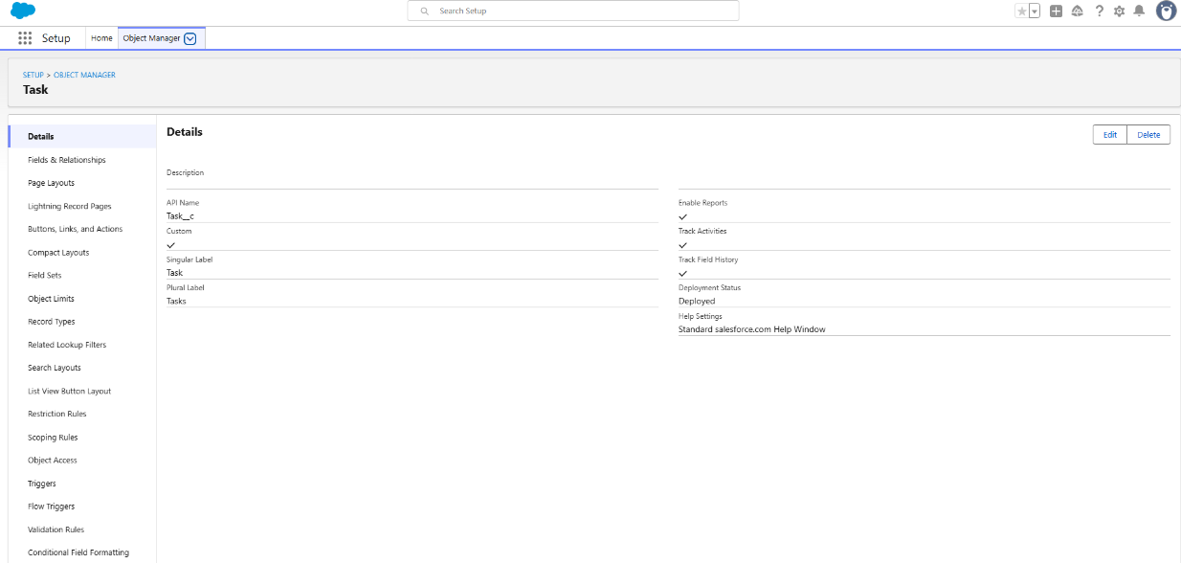

Volunteer:
Manages information about the volunteers, including availability, assigned roles, and contact details, to ensure effective communication and task delegation.

To create an object:

From the setup page >> Click on Object Manager>> Click on Create
>> Click on Custom Object.

- Enter the label name>> Volunteer
- Plural label name>> Volunteers
- Enter Record Name Label and Format
  - Record Name >> Volunteer Name
  - Data Type >> Text
- Click on Allow reports and Track Field History, Allow Activities
- Allow search >> Save

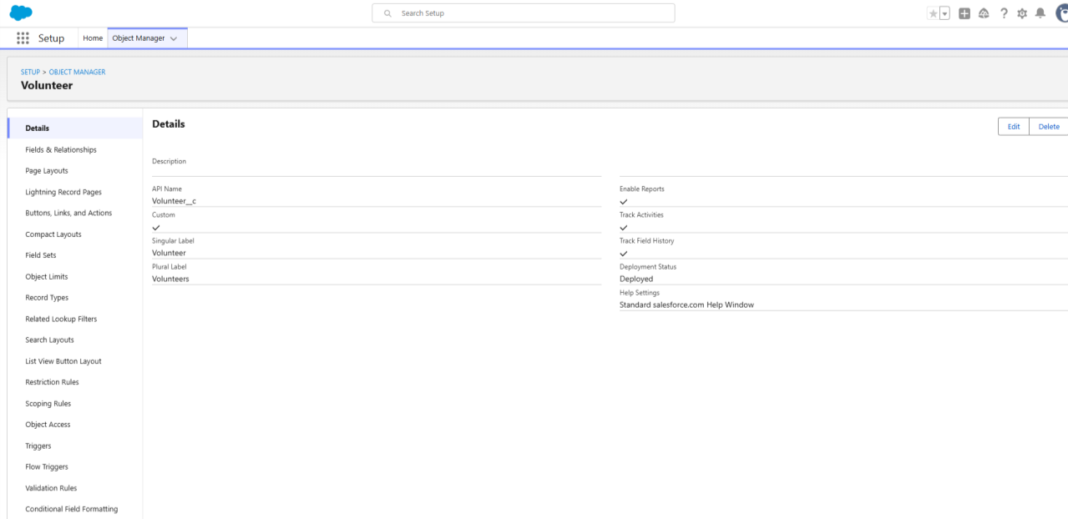

To create an object:

From the setup page >> Click on Object Manager >> Click on Create >> Click on Custom Object.

- Enter the label name >> Execution Detail
- Plural label name >> Execution Details
- Enter Record Name Label and Format
  - Record Name >> Execution Detail Name
  - Data Type >> Text
- Click on Allow reports and Track Field History, Allow Activities
- Allow search >> Save.

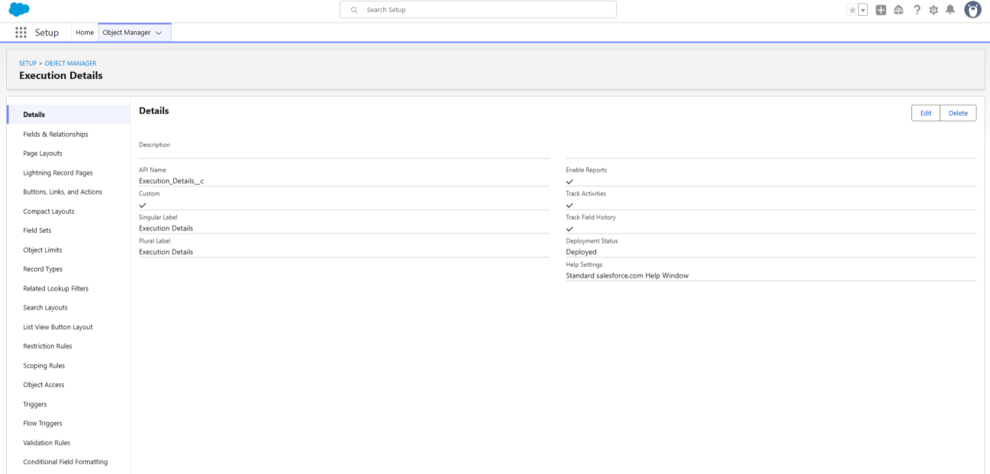

Drop-Off Point:
This object records information about specific locations where food donations are delivered for distribution.

To create an object:

From the setup page >> Click on Object Manager >> Click on Create >> Click on Custom Object.
- Enter the label name >> Drop-Off Point
- Plural label name>> Drop-Off Points
- Enter Record Name Label and Format
  - Record Name >> Drop-Off point Name
  - Data Type >> Text
- Click on Allow reports and Track Field History,Allow Activities
- Allow search >> Save.
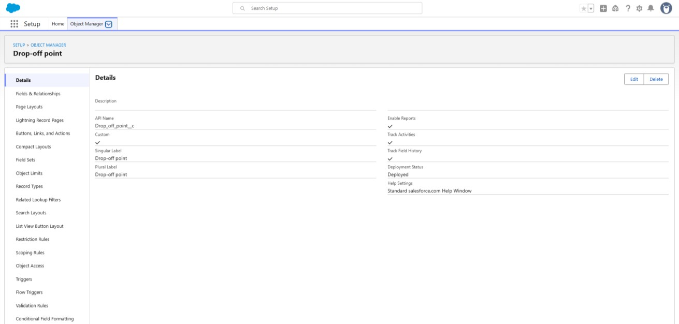

Creation of Custom tabs
To create a custom tab for each of your project’s objects, follow these steps:
- Log in to Salesforce: Ensure you’re logged in with administrator privileges.
- Access Setup: Click the gear icon in the top-right corner and select “Setup.”
- Navigate to Tabs: In the Quick Find box, type “Tabs” and select “Tabs” from the list.

Create New Custom Object Tab:
  - Click New next to "Custom Object Tabs."
  - Select the Object for the tab (e.g., Venue, Drop-Off Point, Execution Details, Volunteer, or Task).
  - Choose a Tab Style (an icon that represents the tab visually).

Tab Label and Visibility:
  - Enter a Label for the tab that will appear to users (e.g., "Venue" for the Venue object).
  - Select Profiles to determine which users will have access to this tab.

Save and Organize:
  - After saving, add the tab to the relevant App (e.g., your project’s custom app for food distribution) so it’s accessible within the application.
Use App Manager to arrange the tabs in your preferred order.
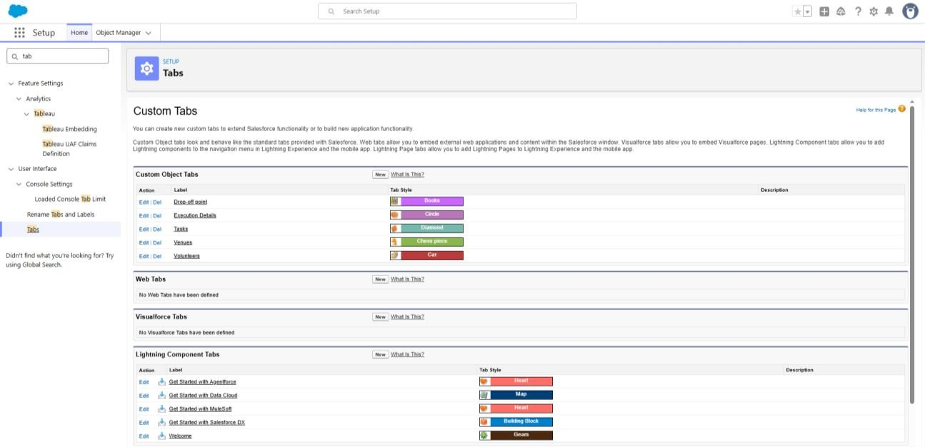

Lightning apps
Lightning Apps in Salesforce consist of a set of tabs and components that work together to enable specific functions. They have a name, logo, and a customizable set of tabs. There are two types of Salesforce applications:
- Standard Apps: Default apps that come with Salesforce (e.g.,
Sales, Marketing, Chatter).
- Custom Apps: Tailored apps with selected standard and custom tabs to
meet specific needs.

creation of lightning apps

- Access App Manager:In Salesforce Setup, type "App Manager" in the Quick Find box and select it.

- Create a New Lightning App:Click on "New Lightning App" and enter the app name (e.g., "Food Supply Management").
- Configure App Options:Set the app's visibility, logo, branding, and any custom settings. Keep the default settings if not specified.

- Utility Bar (Optional):Add tools like Notes or Chat to the app’s utility bar if needed.

- Select Tabs:Choose the objects and tabs you want to include, such as "Venue," "Drop-Off," "Execution Details," "Volunteer," and "Task" for a food distribution app.

- Assign Profiles:Specify which user profiles can access the app by moving relevant profiles (e.g., System Administrator) to "Selected Profiles."

- Save and Launch:Click "Save & Finish" to complete setup. Access the app through the App Launcher to verify that all tabs and settings appear correctly.

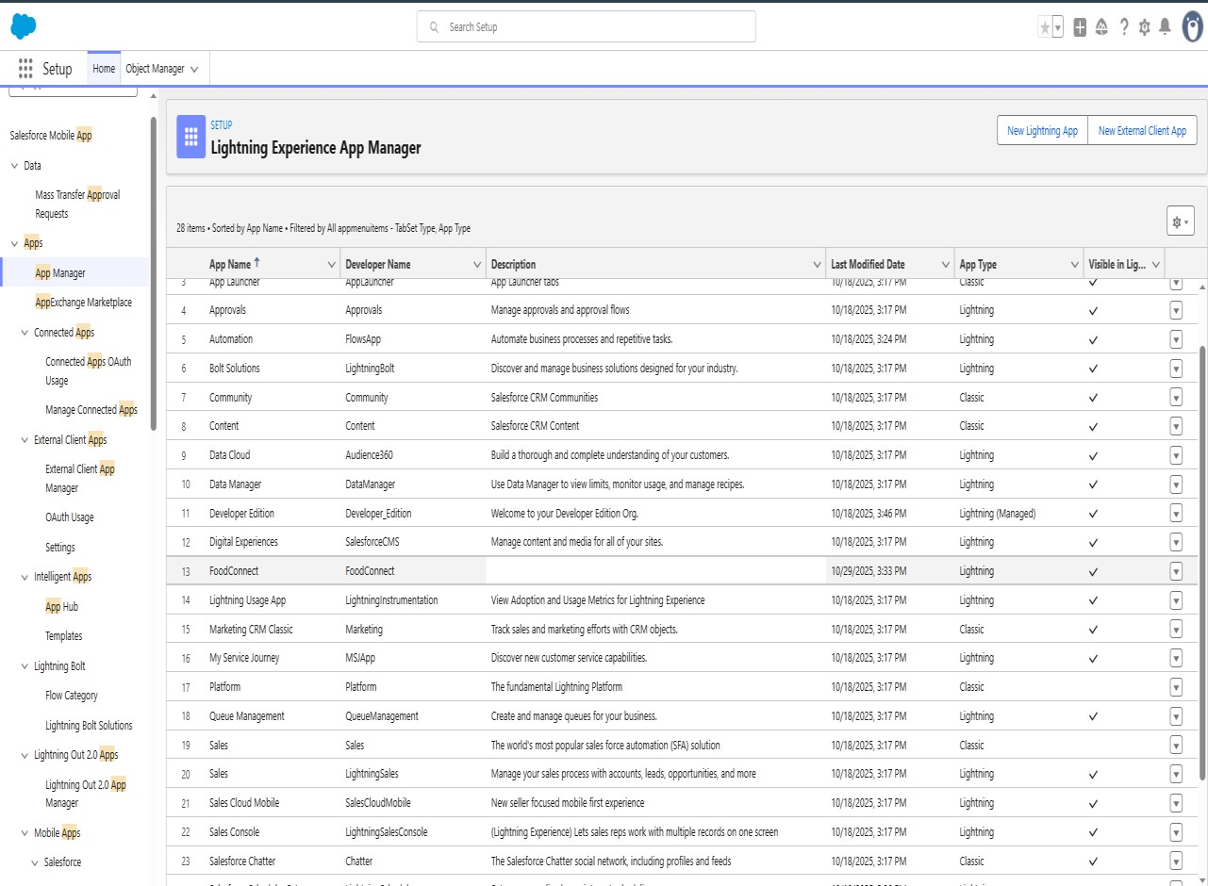

creating fields and relationship fields in object
  - Standard Fields: These are predefined by Salesforce, like "Name" and "Created Date."
  - Custom Fields: Add fields to capture specific information for each object.

Relationship Fields:
  - Lookup Relationship: Links two objects loosely, allowing null values.
  - Master-Detail Relationship: A tighter link where the child object depends on the parent, inheriting permissions and sharing settings.

Creating Relationships:
In Setup, go to the Object Manager.
    - Open the object where you want to add a relationship field.
    - Select Fields & Relationships, then
New. Choose the type of relationship field:
    - For Lookup, select another object to link.
    - For Master-Detail, select the parent object.
    - Set field visibility, add help text, and save.

Creating key objects for fields
- Venue Object
  - Purpose: To store locations where food is available for pickup.

Key Fields:
    - Venue Name (Text): Name of the venue.
    - Address (Text Area): Detailed address of the venue.
    - Contact Number (Phone): Venue’s contact information.
    - Capacity (Number): Maximum amount of food that can be stored at this venue.
    - Venue Type (Picklist): Options like "Restaurant," "Event Hall," or "Catering Service."
    - Status (Picklist): Indicates availability (e.g., Available, Closed).

Relationships:
    - Related to Drop-Off (Lookup or Master-Detail with Drop- Off Point): Shows available drop-off points for each venue.

Drop-Off Point Object
  - Purpose: To track locations where food is delivered.

Key Fields:
    - Drop-Off Location Name (Text): Name of the drop-off point.
    - Distance (Number): Distance from the venue to drop-off point.
    - Address (Text Area): Detailed address.
    - Operational Hours (Text): Hours during which drop-off is accessible.

Relationships:
    - Linked Venue (Lookup or Master-Detail with Venue): Connects each drop-off point to a specific venue for reference.

Task Object
  - Purpose: To track tasks associated with food collection and delivery.

Key Fields:
    - Task Name (Text): Brief name of the task.
    - Description (Text Area): Details about the task.
    - Assigned Volunteer (Lookup with Volunteer): Assigns a volunteer to each task.
    - Due Date (Date): When the task needs to be completed.
    - Priority (Picklist): Options like High, Medium, Low.

Relationships:
    - Related Venue or Drop-Off (Lookup): Links tasks to specific venues or drop-off points as needed.

Volunteer Object
  - Purpose: To manage volunteer details.

Key Fields:
    - Volunteer Name (Text): Full name of the volunteer.
    - Contact Information (Phone): Phone number of the volunteer.
    - Email (Email): Volunteer’s email address.
    - Availability (Picklist): Options like "Available," "Not Available," "Part-Time."

Relationships:
    - Assigned Tasks (Master-Detail or Lookup with Task): Links volunteers to specific tasks.
    - Associated Venues (Lookup or Master-Detail with Venue): Allows linking volunteers to specific venues if needed.

Execution Details Object
  - Purpose: To record details of each food delivery event.

Key Fields:
    - Execution Name (Text): Name of the execution event.
    - Start Date (Date): Start date of the event.
    - End Date (Date): Completion date.

    - Total Food Distributed (Number): Quantity of food distributed.
    - Volunteers Involved (Lookup with Volunteer): Record of volunteers who participated.
    - Challenges Encountered (Text Area): Brief description of any issues faced.

Relationships:
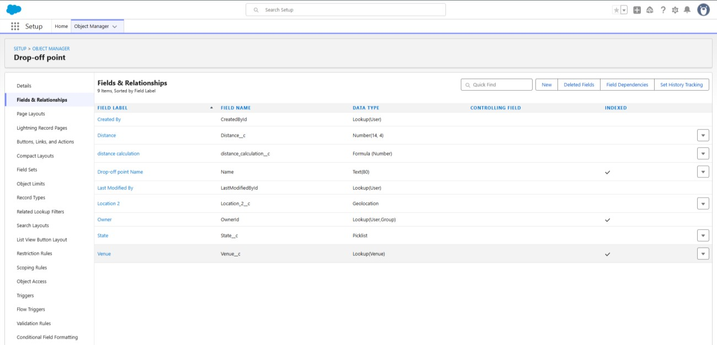
    - Venue and Drop-Off Link (Lookup with Venue and Drop-Off): Links the execution details with specific venues and drop-off points.
Flow
In Salesforce, Flows are powerful automation tools that can automate processes such as record creation, updates, notifications, and complex logic. Here’s an overview of creating flows, and then specifically, setting up a flow to create a record in the Venue object.
  - Screen Flows: Used for guided user input; can be used on pages.
  - Record-Triggered Flows: Automatically trigger on record creation, updates, or deletions.
  - Scheduled Flows: Run on a set schedule to perform routine tasks.

  - Platform Event-Triggered Flows: Triggered by platform events for real- time integration.

Steps to Create a Flow to Add a Venue Record
- Start a New Flow
  - Go to Setup in Salesforce, type Flows in the Quick Find box, and select

Flows.
  - Click New Flow.
  - For this task, select Screen Flow if you want user input for creating a Venue record or Record-Triggered Flow if it should automatically create Venue records under specific conditions.

Configuring the Flow
  - Screen Flow Setup:
    - Step 1: Drag a Screen element from the Toolbox on the left.
    - Step 2: On the screen, add fields that users will fill out, such as Venue Name, Address, Contact Number, Capacity, and any other relevant fields.
    - Step 3: Set component types to match field data (e.g., Text, Phone, Number, Picklist).

Record-Triggered Flow Setup:
    - Step 1: In Trigger the Flow When, select A record is created.
    - Step 2: Choose the object and specify any criteria that should trigger the record creation.

Adding the Create Record Element
  - Click + Add Element in the flow canvas and select Create Records.
  - Label the action, for example, "Create Venue Record."
  - Select the Venue Object: Choose Venue as the object where the record will be created.

Define the Field Values
  - Map the fields in the Venue object to the corresponding input fields or variables:

    - Venue Name: Map to the name input provided by the user or predefined value.
    - Address: Link to a text input field.
    - Contact Number: Map to the phone input field.
    - Capacity: Map to the number input field.
  - Choose Fields and Set Values: Ensure that required fields are mapped.

Save and Activate the Flow
  - Click Done to save the element setup.
  - Save the Flow with a descriptive name, such as "Create Venue Record Flow."
  - Activate the flow by clicking Activate in the Flow Builder toolbar.
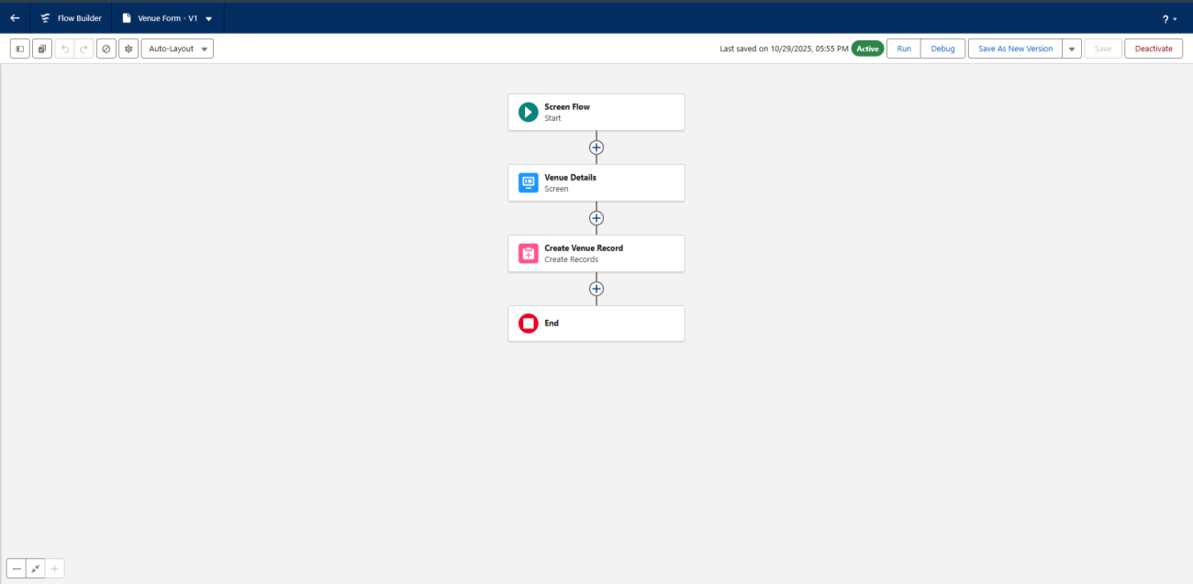

Testing And Validation Trigger
To create a trigger in Salesforce that automatically creates a record in the Venue object based on a specific condition or event, you'll need to write an Apex Trigger. Here’s a step-by-step guide, along with an example trigger.

Steps to Create a Trigger in Salesforce
- Access Developer Console:
  - In Salesforce, click the Gear Icon (⚙️) and select Developer Console.

Create a New Trigger:
  - In the Developer Console, go to File > New > Apex Trigger.
  - Choose the object you want the trigger to be associated with. For instance, if you want the trigger to create a Venue record when a Task record is created, select the Task object.
  - Name the trigger (e.g., CreateVenueOnTaskTrigger).

Define the Trigger Logic:
  - Define when the trigger should fire, such as before insert or after insert.
  - Specify the actions the trigger will take, such as creating a new
Venue record.

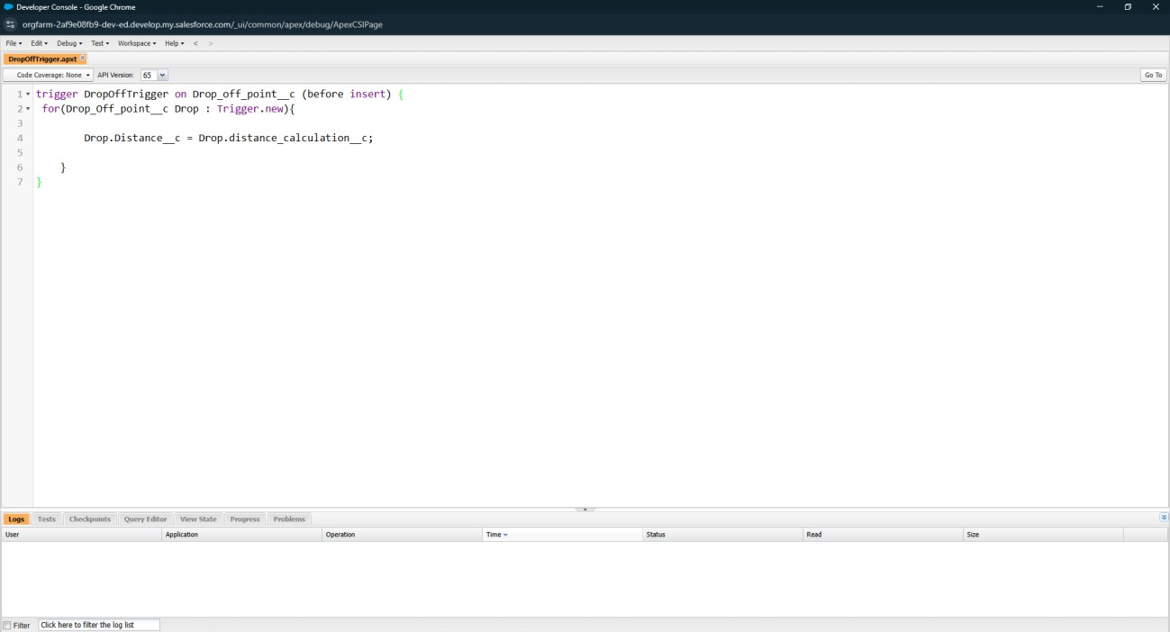

Steps to Create and Configure Profiles in Salesforce
- Accessing Profiles
  - In Setup, type Profiles in the Quick Find box and select Profiles.
  - You will see a list of existing profiles, including both standard and custom profiles.

Creating a New Profile
  - To create a custom profile, you can either clone an existing profile or start from scratch.

Clone a Profile:
    - Select a standard profile (like "Standard User") that closely matches the permissions you need.
    - Click Clone to create a new profile based on this existing profile.

Configuring Profile Settings
  - Profile Name: Name your profile, e.g., "Venue Manager" or "Volunteer Coordinator".

Object Permissions:
    - Scroll down to Custom Object Permissions.
    - For each custom object (e.g., Venue, Drop-Off Point, Task, Volunteer, Execution Details), set the appropriate permissions:
      - Read: Allows viewing records.
      - Create: Allows creating new records.
      - Edit: Allows editing existing records.
      - Delete: Allows deleting records.
    - For example, a "Venue Manager" profile might have full access to the Venue object but limited access to other objects.

Field-Level Security:
    - Go to each custom object and specify Field-Level Security for each field.
    - Set fields to Read-Only or Hidden if certain data should not be edited or viewed by this profile.

Tab Settings:
    - Under Tab Settings, control which tabs users with this profile can see.

- Set each tab (e.g., Venue, Task) to Default On, Default Off, or

Hidden.
- App Settings:
  - Assign this profile to specific apps, such as the Food Connect
app you created.
  - Under Assigned Apps, select the apps that should be visible to users with this profile.

Page Layout Assignment:
  - For each object, assign a Page Layout to control how information is displayed to users.
  - For instance, for the Venue object, a manager might see more detailed layouts, while volunteers see a simpler version.

Assigning Profiles to Users
  - After setting up a profile, assign it to users.
  - Go to Setup > Users, find the user, and edit their profile to assign the new custom profile

Creation of Users
- Go to setup page >> type users in Quick Find bar >> click on users>> New user.
- In General Information give details as: (Note : create users as per your wish NGO’s)
FirstName: Iksha Foundation LastName: Iksha_Foundation Alias : iiksh
Email : Give Your Email
Username : ikshafoundation@sb.com (give the username different)
Nickname : Auto Populated
User License : Salesforce Platform Profile : NGOs Profile
Active : Check

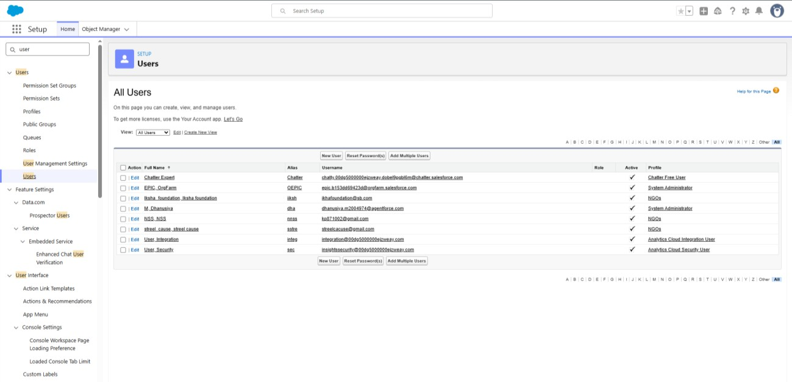

Creation of public group1&2
- Go to setup page >> type Public Groups in Quick Find bar >> click on Public Groups >> click on New.
- Under Group Information:
  - Label : Iksha
  - Group Name : Iksha
  - Grant Access Using Hierarchies : Check
- In Search, Select Users.
- In Selected Members Add Iksha Foundation and System Administrator
- By Following Steps in Activity 1, Create other two Public Groups for other two users.
- After Saving this would look like this.

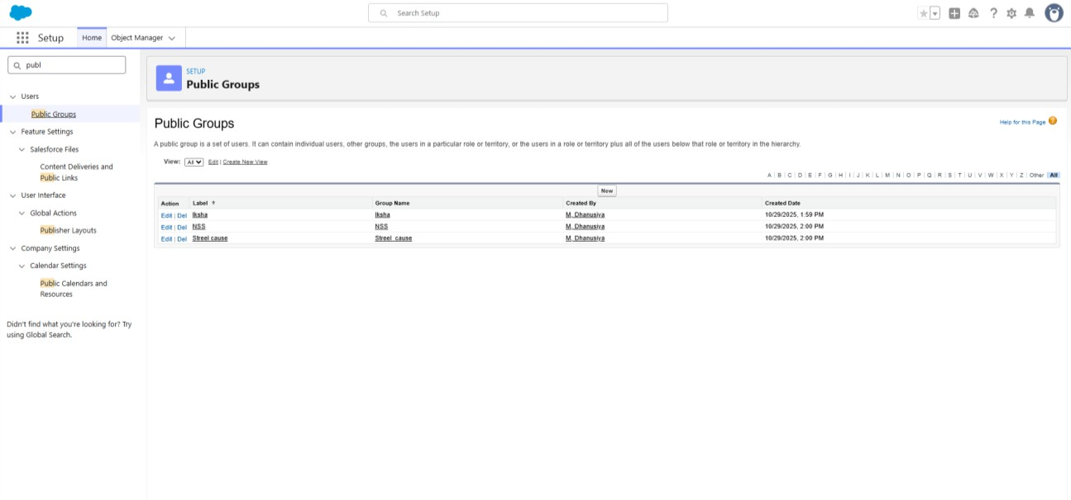

Creation of report types
- Go to setup page >> type Report Types in Quick Find bar >> click on Report Types >> click on Continue >> Click on New Custom Report Type.
- In Define the Custom Report Type:
  - Primary Object : Select Venues
  - Report Type Label : Venue with Drop Off with Volunteer
  - Report Type Name : Venue_with_Drop Off_with_Volunteer
  - Description : Venue with Drop Off with Volunteer
  - Store in Category : Select Other Reports
  - Deployment Status : Deployed
- Click on Next
- Near Click to relate another Object Select Drop-Off Points.
- And also select "A" records may or may not have related "B" records.
- Now again Near Click to relate another Object Select Volunteers.
- Now click on Save.

I. Creation of Report on Venue with Drop Off with Volunteer
- Go to the app(Food Connect) >> click on the reports tab
- Click on New Folder.
Folder Label : Custom Reports
Folder Unique Name : Custom Reports

- Open Custom Reports and click on New Report
- Select Report Type : Venue with Drop Off with Volunteer
- Then click on Start Report.
- In GROUP ROWS : Add Volunteer Name
- In Columns : Add Venue Name, Drop-Off point Name, Distance.
- Now click on Save & Run.
- Give Label as :
- Report Name : venue and Drop Off point
- Report Unique Name : Auto Populated
Click on Select Folder and select Custom Report, then click on Save.

I. Creation of Report on Volunteers with Execution Details and Tasks
- Go to the app(Food Connect) >> click on the reports tab
- Click on Custom Reports Folder and click on New Report
- Select Report Type : Volunteers with Execution Details and Tasks.
- Then click on Start Report.
- In GROUP ROWS : Volunteer ID
- In Columns : Add Volunteer : Volunteer Name, Task : Task Name, Execution Detail : Execution Detail Name, Volunteer: Owner Name, Task: Date, Task : Rating.
- Now click on Save & Run.
- Give Label as :
Report Name : Volunteer Task
Report Unique Name : Auto Populated
Click on Select Folder and select Custom Report, then click on Save
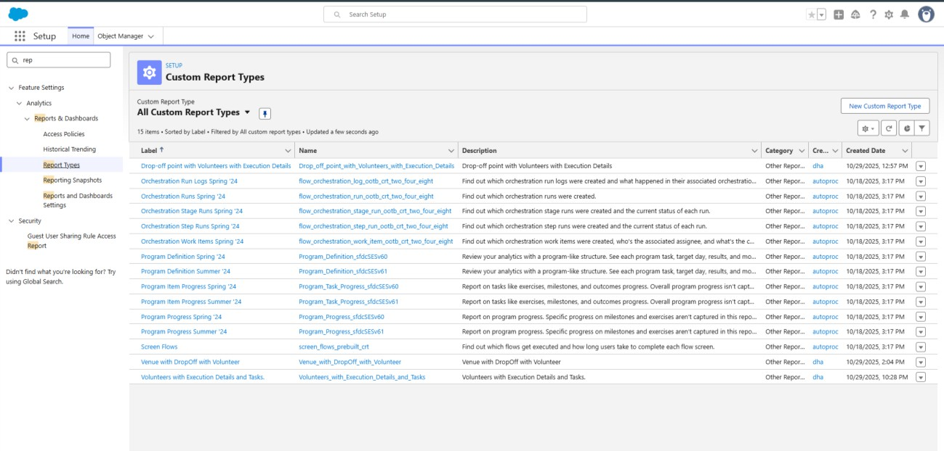

Steps to Create a Dashboard in Salesforce
  - Access Dashboards:
    - Go to the Dashboards tab in Salesforce.
    - Click New Dashboard to create a new dashboard.

Set Dashboard Properties:
    - Name: Enter a name, such as "Food Distribution Overview."
    - Description: Provide a brief description of what the dashboard tracks, e.g., "Tracks venues, volunteer tasks, and distribution statistics."
    - Folder: Select a folder to save the dashboard. This controls visibility for other users.
    - View As: Set who should be the running user for the dashboard. This setting defines whose data permissions are applied when viewing the dashboard.

Add Dashboard Components:
    - Click + Component to add a report component to the dashboard.
    - Choose a report to use (only saved reports can be added).
    - Select a Component Type (e.g., bar chart, pie chart, table) that best represents the data.
    - Customize the component’s settings, including title, display units, and colors.

Arrange and Customize Components:
    - Resize and Reposition: Drag components to rearrange and resize them for better visual flow.
    - Component Details: Edit each component’s title and subtitle to ensure they’re descriptive (e.g., “Tasks Completed by Volunteers” or “Food Distributed by Venue”).
    - Apply Filters: Set global filters for the dashboard, such as filtering by time period or specific locations, which will apply to all components.

Save and View Dashboard:
    - Click Save to save your progress.

Adding venue and Drop Off point Report to the Dashboard
  - Go to the app(Food Connect) >> click on the Dashboards tab.
  - Click on New Folder.
Folder Label : Custom Dashboards

Folder Unique Name : Auto Populated
  - Open Custom Dashboards and click on New Dashboards
  - Name : Organization Details
  - Click on Widget and select Chart or Table
  - In Select Report : Select venue and Drop Off point Report.
  - Then click on select
  - In Add Component:
Display As : Select Lightning Table Component Theme : Select Dark (Optional) Now click on save.

Adding Volunteer Task Report to the Dashboard
  - Click on Widget and select Chart or Table
  - In Select Report : Select Volunteer Task Report.
  - Then click on select
  - In Add Component:
Display As : Select Line Chart
Component Theme : Select Dark (Optional)

Adding a Picture to the Dashboard
  - Click on Widget and select Image. Then click on Browse Files.
  - Then Select the Picture you want to upload in this Dashboard.
  - Then click on Save As :
    - Name : Task Execution Details
    - Click on Select Folder and select Custom Dashboards
  - Click on Select Folder and then Save.
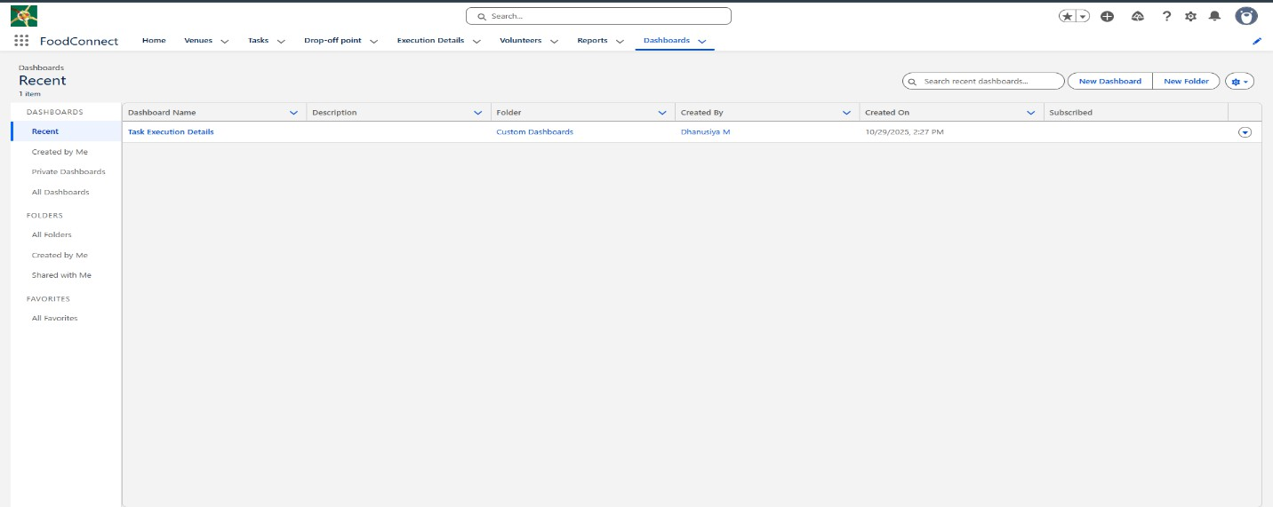

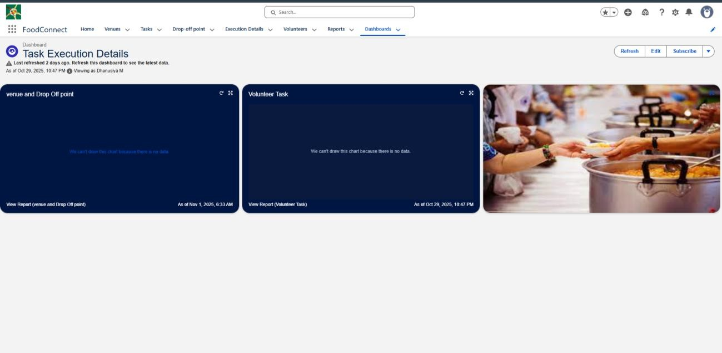

Creation of sharing rules
- Go to setup >> type Sharing Settings in quick find box >> Click on the Sharing Settings.
- Scroll down and find Drop-Off point Sharing Rules.
- Click on new near Drop-Off point Sharing Rules and Name it as:
  - Label : Rule 1
  - Rule Name : Rule_1
- Select your rule type : Select Based on criteria.
- Select which records to be shared:
  - Field : Operator : Value = Distance : less than : 15
- Select the users to share with : Near Share With
  - Public Groups : Iksha
- Click on Save.
- Click on new near Drop-Off point Sharing Rules and Name it as:
  - Label : Rule 2
  - Rule Name : Rule_2
- Select your rule type : Select Based on criteria.
- Select which records to be shared:
- Field : Operator : Value = Distance : greater than : 15
- Field : Operator : Value = Distance : less or equal : 30
- Select the users to share with : Near Share With
  - Public Groups : NSS
- Click on Save.
- Click on new near Drop-Off point Sharing Rules and Name it as:

  - Label : Rule 3
  - Rule Name : Rule_3
- Select your rule type : Select Based on criteria.
- Select which records to be shared:
  - Field : Operator : Value = Distance : greater than : 30
  - Field : Operator : Value = Distance : less or equal : 50
- Select the users to share with : Near Share With
  - Public Groups : Street Cause
- Click on Save.

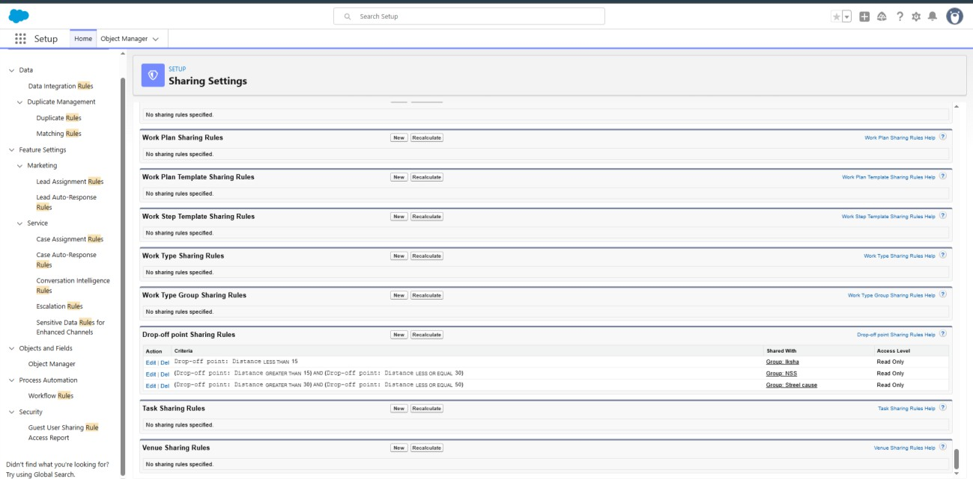

Creation of Home Page
- Go to setup >> type Lightning App Builder in quick find box >> Click on the Lightning App Builder and Select the New.
- Select Home Page and give Label as HOME Page.
- Select Standard Home Page.
- Near Components search for Flow and Drag and Drop in Right Side Section..
- On the right hand side:
Flow : Venue Flow
- Near Components search for Dashboard, then Drag and Drop it in first Section
- Click on Save and Activation, then click on App Default, then Add Assignments.

- Add Food Connect App and then Save.
- Food Connect Home Page would Look Like this.

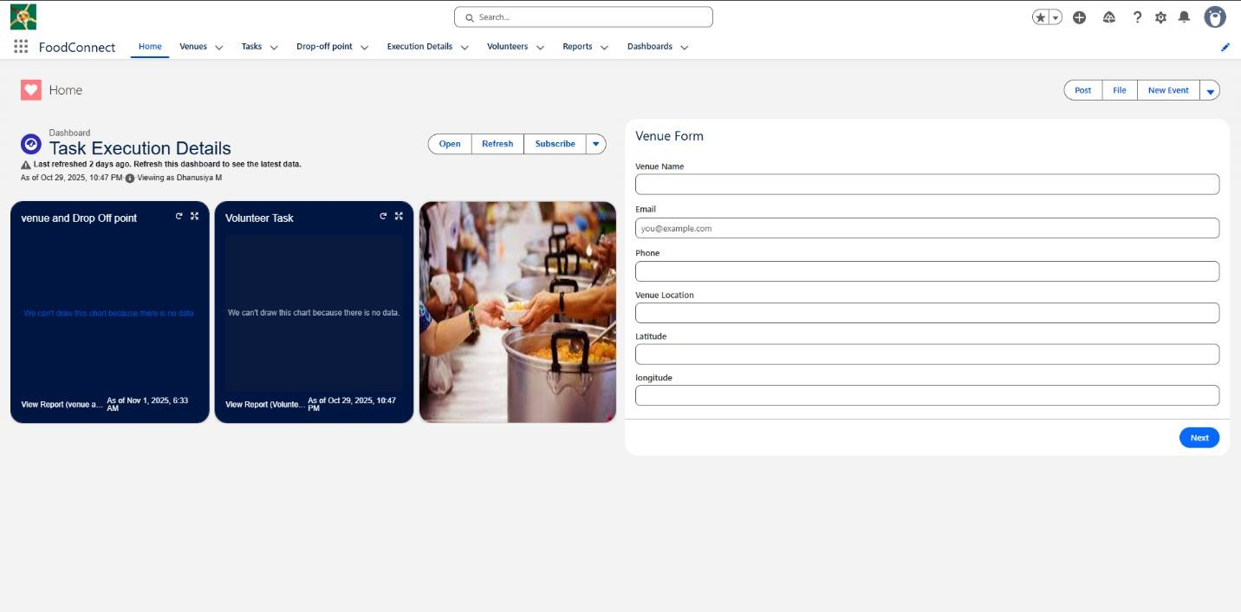

Goals:
  - Streamline Food Collection – Enable donors to easily register and donate leftover food.
  - Centralize Data Management – Use Salesforce to store and manage donor, volunteer, and recipient data.
  - Optimize Logistics – Automate routes and volunteer assignments for efficient food delivery.
  - Track and Report – Monitor donation flows and generate reports to improve operations.
  - Enhance Communication – Keep donors and volunteers informed through updates and alerts.
  - Ensure Food Safety – Maintain quality standards and train volunteers in food handling.
  - Plan for Expansion – Build a scalable system to support future growth in different regions.
  - Raise Awareness – Use marketing tools to engage the community and attract more support.

Conclusion
The Food Distribution Project in Salesforce optimizes the process of collecting and distributing leftover food to those in need. By using Salesforce objects for Venue, Drop-Off Point, Task, Volunteer, and Execution Details, the project enables efficient tracking of food collection sites, distribution locations, and volunteer assignments. Automation through flows and triggers reduces manual tasks, while custom profiles and sharing rules ensure data security, allowing users to access only the information relevant to their roles.
Real-time dashboards and reports provide valuable insights into distribution metrics, volunteer activity, and task progress, supporting data-driven decisions and resource allocation. A customized Home Page streamlines navigation by displaying recent activity, key metrics, and quick links. Overall, Salesforce empowers the project with enhanced organization, accountability, and scalability, making it an effective tool for addressing food distribution challenges and supporting communities in need.

